**CURRICULUM VITAE**

# Objective statement:

Working with an organization in enhancing effective cooperation with other co-workers within and outside the organization so as to enhance organization’s efficiency at a maximum level and national economic growth at large.

**PERSONAL PARTICULARS**

Name Janeth Beilly

Age 29 Years

Sex Female

Nationality Tanzania

Phone +255 684320692

Email [basakajane@gmail.com](mailto:basakajane@gmail.com)

**EDUCATION BACKGROUND**

**COLLEGE OF BUSINESS EDUCATION (2010-2013**)

Diploma of Business Administration

**O-LEVEL**

BREAK THROUGH HIGH SCHOOL (2006-2009)

Certificate Of Secondary Education Examination (CSEE)

**PRIMARY LEVER**

BUNGE PRIMARY SCHOOL (1999-2005)

Certificate of Primary Education

# WORKING EXPERIENCE

# DR. MEHTA’S HOSPITAL - ZANZIBAR. (February, 2014 to January 2016)

* Welcomes and greets all patients and visitors, in person or over the phones
* Responsible for keeping the reception area clean and organized
* Registers [new patients](http://medicaloffice.about.com/od/J-P/g/patientresponsibility.htm) and updates existing patient demographics by collecting patient detailed patient information including personal and financial information
* Facilitates patient flow by notifying the provider of patients’ arrival, being aware of delays, and communicating with patients and clinical staff
* Handling incoming and outgoing mail Protects patient confidentiality.

**Pongwe Bay Beach Resort (May 2016 – Dec 2017)**

* Receptionist Cashier
* dealing with bookings
* completing procedures when guests arrive and leave
* choosing rooms and handing out keys
* preparing bills and taking payments
* taking and passing on messages to guests
* dealing with special

**Zan Air (July 2018)**

As Sales and Reservations Officer:

* dealing with bookings
* completing procedures when guests arrive and leave
* preparing bills and taking payments
* taking and passing on messages to passengers
* dealing with special requests from passengers
* answering questions
* dealing with complaints or problems
* Confirming reservations and then selling tickets to the passengers.
* Checking baggage.
* To Provide friendly services to and maintains positive relationships with all internal and external Customers
* Communicates with Customers by telephone to furnish information regarding fares, schedules, routings, flights and availability of space.

**APOLLO MEDICAL CENTRE (23-08-2019 TO 23-08-2020)**

As Front Office Supervisor:

* Reception Cell phone - checks the balance and top up the package if needed.
* Clinics - Confirm With the specialist Doctors first thing in the morning before accepting any Cash or insurance patients.
* Organizing the cupboard – ensure jubilee, strategies & admission form files are placed in order.
* Recheck count of Forms 2A Books (NHIF) if less I ask Messenger to add.
* Calling Patients - All patients who have booked an appointment with the specialist should be given a call ( reminder )
* Ipd Forms - All the Ipd patient forms from the front desk white drawer should be filed in the black file which is in Pharmacy.
* Organizing files - All files sent back by specialist doctors should be returned in their Respective order after they are recorded. Receiving cash patients.
* Close all daily sales and monthly report.

**KARIBU BEACH RESORT ZANZIBAR (19-10-2020 TO 08-03-2022)**

Front Office Manager:

* Direct operations at the front desk and ensure customer service meets our high standards for guest satisfaction.
* Hire, train, and supervise front office employees, ensuring they provide excellent guest services and enforce hotel policies.
* Interact with customers both in person and over the phone, assist with inquiries, and mitigate any guest complaints.
* Handle the front desk budget and order office supplies as needed.
* Compile occupancy reports and financial information for the general manager.
* To prepare end of the month ZRB and TRA payment report.
* Dealing with all the hotel reservations.
* Supervises workload during shifts.
* Maintains master key control.
* Monitor all V.I.P’s special guests and requests.
* Ensure that employees are, at all times, attentive, friendly, helpful and courteous to all guests managers and other employees.
* Wears the proper uniform at all times. Requires all front office employees to wear proper uniforms at all times.
* Conducts regularly scheduled meetings of front office personnel.
* Operate all aspects of Front Office computer system, including software maintenance, report generation and analysis, and simple configuration changes.
* Perform other duties as requested by management.

# PERSONAL ATTRIBUTIES

* Committed and Fast learner,
* Persistent and Courteous,
* Flexible &Accountable,
* Innovative, proactive and able to work under pressure while meeting deadlines,
* Trustworthy and God – fearing,
* Level-headed, confident and self-motivated,
* Hardworking, goal & result oriented with good communication skills
* Easily adapts in multi-ethnic, multi-cultural &evolving environment, and
* Honest, loyalty and keen to learn (Integrity).

# OTHER SKILLS.

* Communication skills (English & Swahili language)
* Computer skills particularly; Microsoft word, Microsoft excels including spread sheet, Microsoft Publisher, Email and Internet, and Power point,
* Leadership & Management skills,
* Diversity and Multi – cultural skills,
* Team working skills, and
* Peer education & Entrepreneurs skills.

# HOBBIES, INTERESTS & GOALS

Wide reading magazines, browsing the internet, listening and watching TV& the radio, travelling, visiting, doing physical exercise and learning other languages

# F. REFFERENCES

* 1. Mr Estomieh Samuel Shemahonge

Support services & Marketing manager

0715400960

* 1. DR. Jane Simpson

Front Office Manager

Zanzibar

0716428959

* 1. Emanuel Abraham Machenje

Reservation and check-in officer

0718212093

* 1. Mr Samwel Basaka

0754669663

* 1. Hamza Ridhiwani Msuya

Human resources manager

0719533531

I, JANETH BEILLY certify that all the information stated in this CV is true and complete to the best of my knowledge.

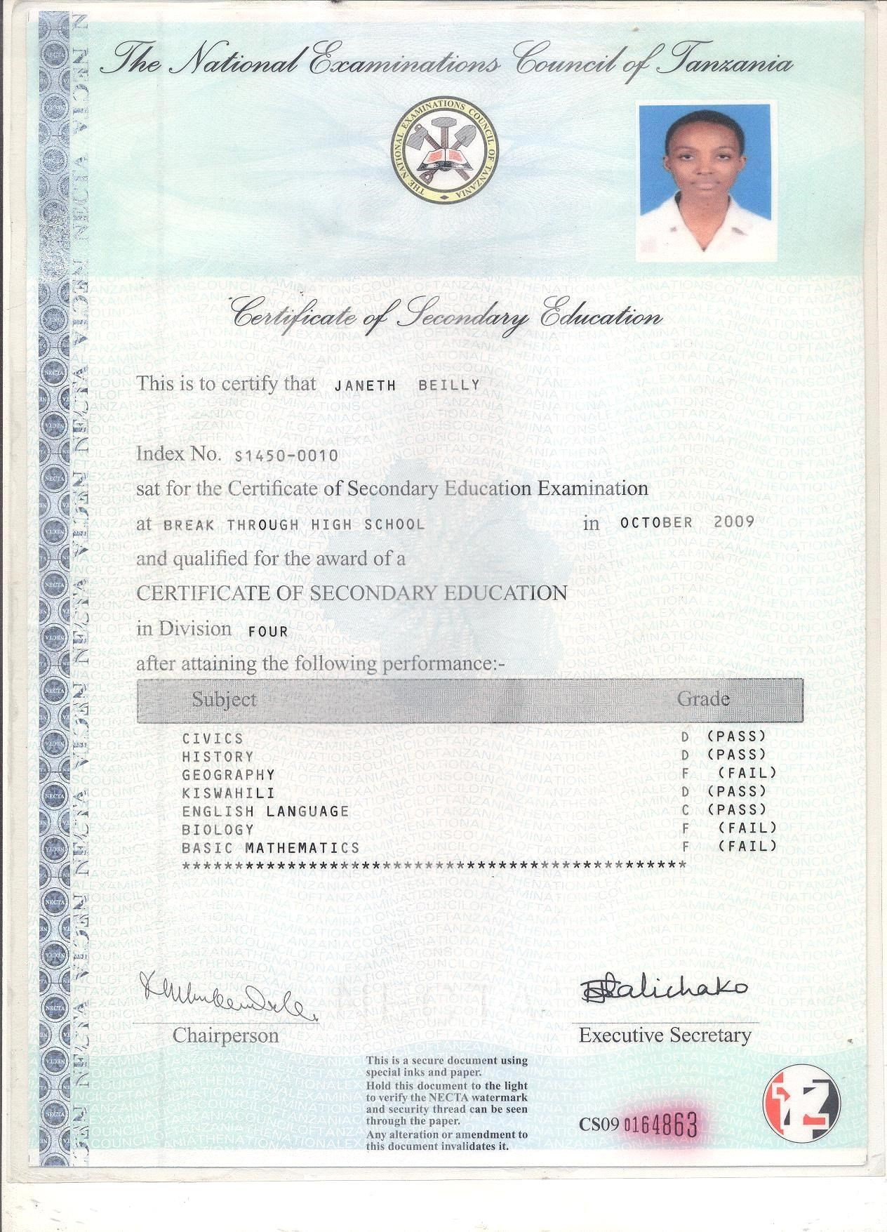

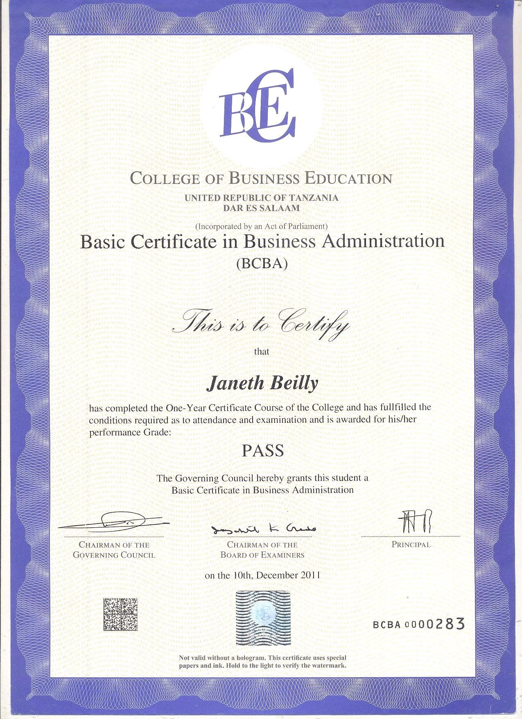

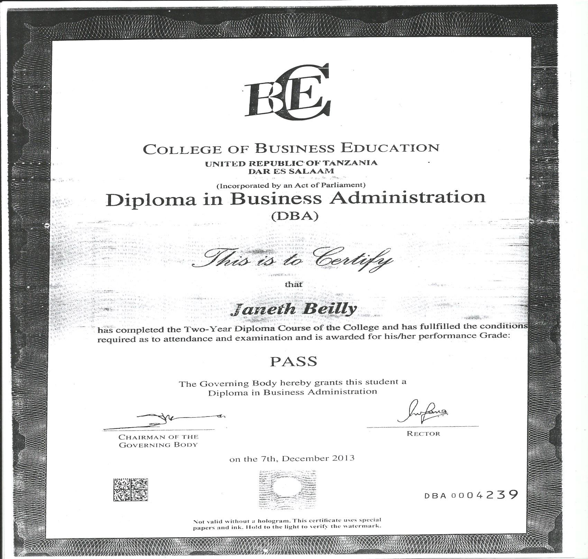

Respective Sir/Madam,

My name is Janeth Beilly Basaka, a Tanzanian woman aged 27years old I would very much like to express my interest to be part of your organization. I feel that I am qualified to the qualifications that you are looking for.

I am college graduate and have held a few positions before. My experience in office work and management is quite extensive and I am ready to handle any tasks which a position in your company may require. I am computer literate and know how to talk and deal with people. I have enclosed my credentials with his letter including my curriculum vitae. Should you want to have more details on my qualification, you can refer to it.

I am willing to submit to an interview at your convenience. I have included my contact numbers with my credentials. Please feel free to contact me anytime.

Thank you very much and I hope you will consider my application.

Yours sincerely,

Janeth B Basaka.