**CURRICULUM VITAE**

**Personal Details:**

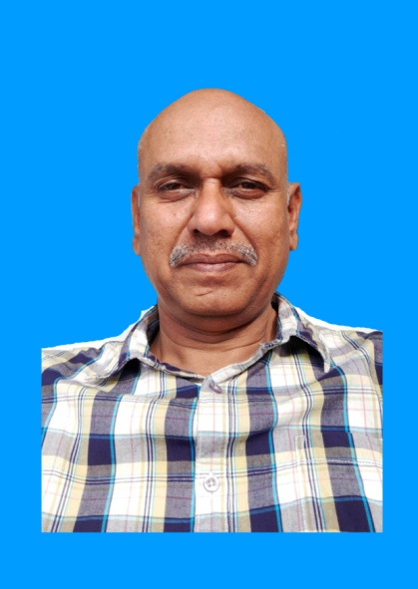Name : SUBHANI BASHA SYED

Nationality : INDIAN

Passport Status : P4546305

Date of Birth : 01st June, 1969

Marital Status : MARRIED

Permanent Address : PLOT No. 78 – SSS COLONY

GOLLAPUDI – 521225

VIJAYAWADA

ANDHARA PRADESH – INDIA

Temporary Address : DODOMA

Contact Details : E-mail: [syedsubbu@gmail.com](mailto:syedsubbu@gmail.com)

MOBILE: +255 789 828 377

+91 80 19 20 19 93

Languages known : English, Hindi and Telugu, Swahili

**Professional overview**

* A result oriented professional with over 28 years experience in Administration & Operational Management, Coordination and team manager.
* Astute officer with a flair for adopting modern Accounting methodologies with Tally & Focus, systems in compliance with quality standards.
* Expertise in swiftly ramping up Administration work with competent cross-functional skills and on time finished work.
* Exemplary relationship management, communication skills with the ability to network with customer, project members, consultants, contractors, and statutory agencies with consummate ease.
* An effective communicator with exceptional relationship management skills with ability to relate to people at any level of business.

**Professional Qualification**

1. S.S.C from Salvation Army High School, Bapatla, Guntur District AP.
2. Intermediate from William Booth College, Bapatla, Guntur District AP.
3. B.Com from Arts & Science College, Bapatla (Nagarjuna University) AP

**Computer Qualification**

1. MS OFFICE: Word, Excel, PowerPoint, Internet, E-mail applications.
2. Diploma in Computer Application & P.G.D.C.A – Hyderabad.
3. Tally Account & Audit full work Experience – Computers.

**WORK EXPERIENCE**

28 Years overall and 8 years in Tanzania and Kenya

JUNE 2019 – TILL NOW: STORES, OPERATIONS AND ACCOUNTS

PRISCUS ALEXANDER COMPANY LTD

DODOMA – TANZANIA

JAN 2017 – MAY, 2019: GENERAL MANAGER

SURYA MILK DAIRY

NALGONDA – TELANGANA

AUG, 2014 – SEPT, 2016: GENERAL MANAGER

SUNANDINI MILK DAIRY (GVR FOOD PRODUCTS)

KHAMMAM – TELANGANA

MAR, 2011 – JULY, 2014: FINANCE AND ACCOUNTS MANAGER

PREMIER COOKIES LTD & POLYSACK LTD

PREMIER GROUP OF COMPANYS

NAIROBI – KENYA.

MAR, 2010 – MAR, 2011: ACCOUNTS AND ADMINISTRATION

SIVANADINI MILK DAILY

ADDANKI – ANDHARA

MAR, 2008 – FEB, 2010: ACCOUNTANT & OPERATIONS

VICTORIA MOULDERS & POLY BAGS

MWANZA – TANZANIA

1997 – 2008: RAVILEELA DAILY PRODUCT LTD - HYDERABAD

*Working as a Accountant and procurement & marketing and plant manager for 6 years experience.*

VELUGU – DRDA – KHAMMAM – TELANGANA – AP

*Worked as a project Assistant CIF for 2 years experience (World Bank funds)*

SVM CENTRAL PUBLIC SCHOOL – KHAMAMA – TELANGANA

*Worked as a Accounts & Administrative Officer for 2 years experience*

**STRENGTHS:**

Strong Accounting & Administrative & stores knowledge, Decent team work Sense of responsibility; highly inquisitive, Creative and resourceful. Confident and dedicative toward Jobs and given responsibilities.

________________________

**SYED SUBHANI BASHA**

[syedsubbu@gmail.com](mailto:syedsubbu@gmail.com)