**EDSON FELIX MSIMAMI.**

Email: edsonmsimami@gmail.com. Mobile +255766902040. Arusha, Tanzania.

Danvast

P.O.Box

Dar es Salaam.

Dear Hiring team.

**RE: SALES MAN.**

I am a University graduate from the University of Eckernforde Tanga where I graduated with Bachelor of Arts with education in 2018, aged 34.

I am writing to express my interest inSales Man post at your company Danvast Limited because I am highly skilled and experienced in managing team performance and cooperating with a team. I am able to monitor assessment and promote team work, with the experience of 8 years.

I have gained this experience though learning and working in the field. My experience is to work as Bland Ambassador and Team leader, Trade development representative and Cluster Supervisor at Vodacom, Area Sales supervisor at Azampesa, Volunteer as Executive Secretary and Treasurer at PHAMT Church Arusha Olasiti parish. Besides that I have attended various trainings and seminars organized by Vodacom Tanzania plc and Tigo plc which have equipped me with necessary skills such as products and services, customer care, sales skills, stock management and investment and computer skills of which I think your company is looking for. Other qualifications which I possess will be evident in the attached resume which I have enclosed in this letter. I am looking forward to receiving a positive response from you.

Yours faithfully

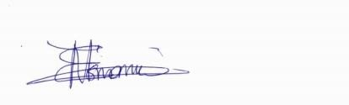

**Edson Felix Msimami.**