G~~en~~de~~r:~~ Male

Natio~~n~~al~~i~~ty~~:~~ Tanzanian

Date of b~~i~~rth: 12.11.1997 Pho~~ne:~~ 0621747463 Ema~~i~~l~~:~~

bashirumanzi62@gmail.com

Bashiru Manzi

Marketing Manager

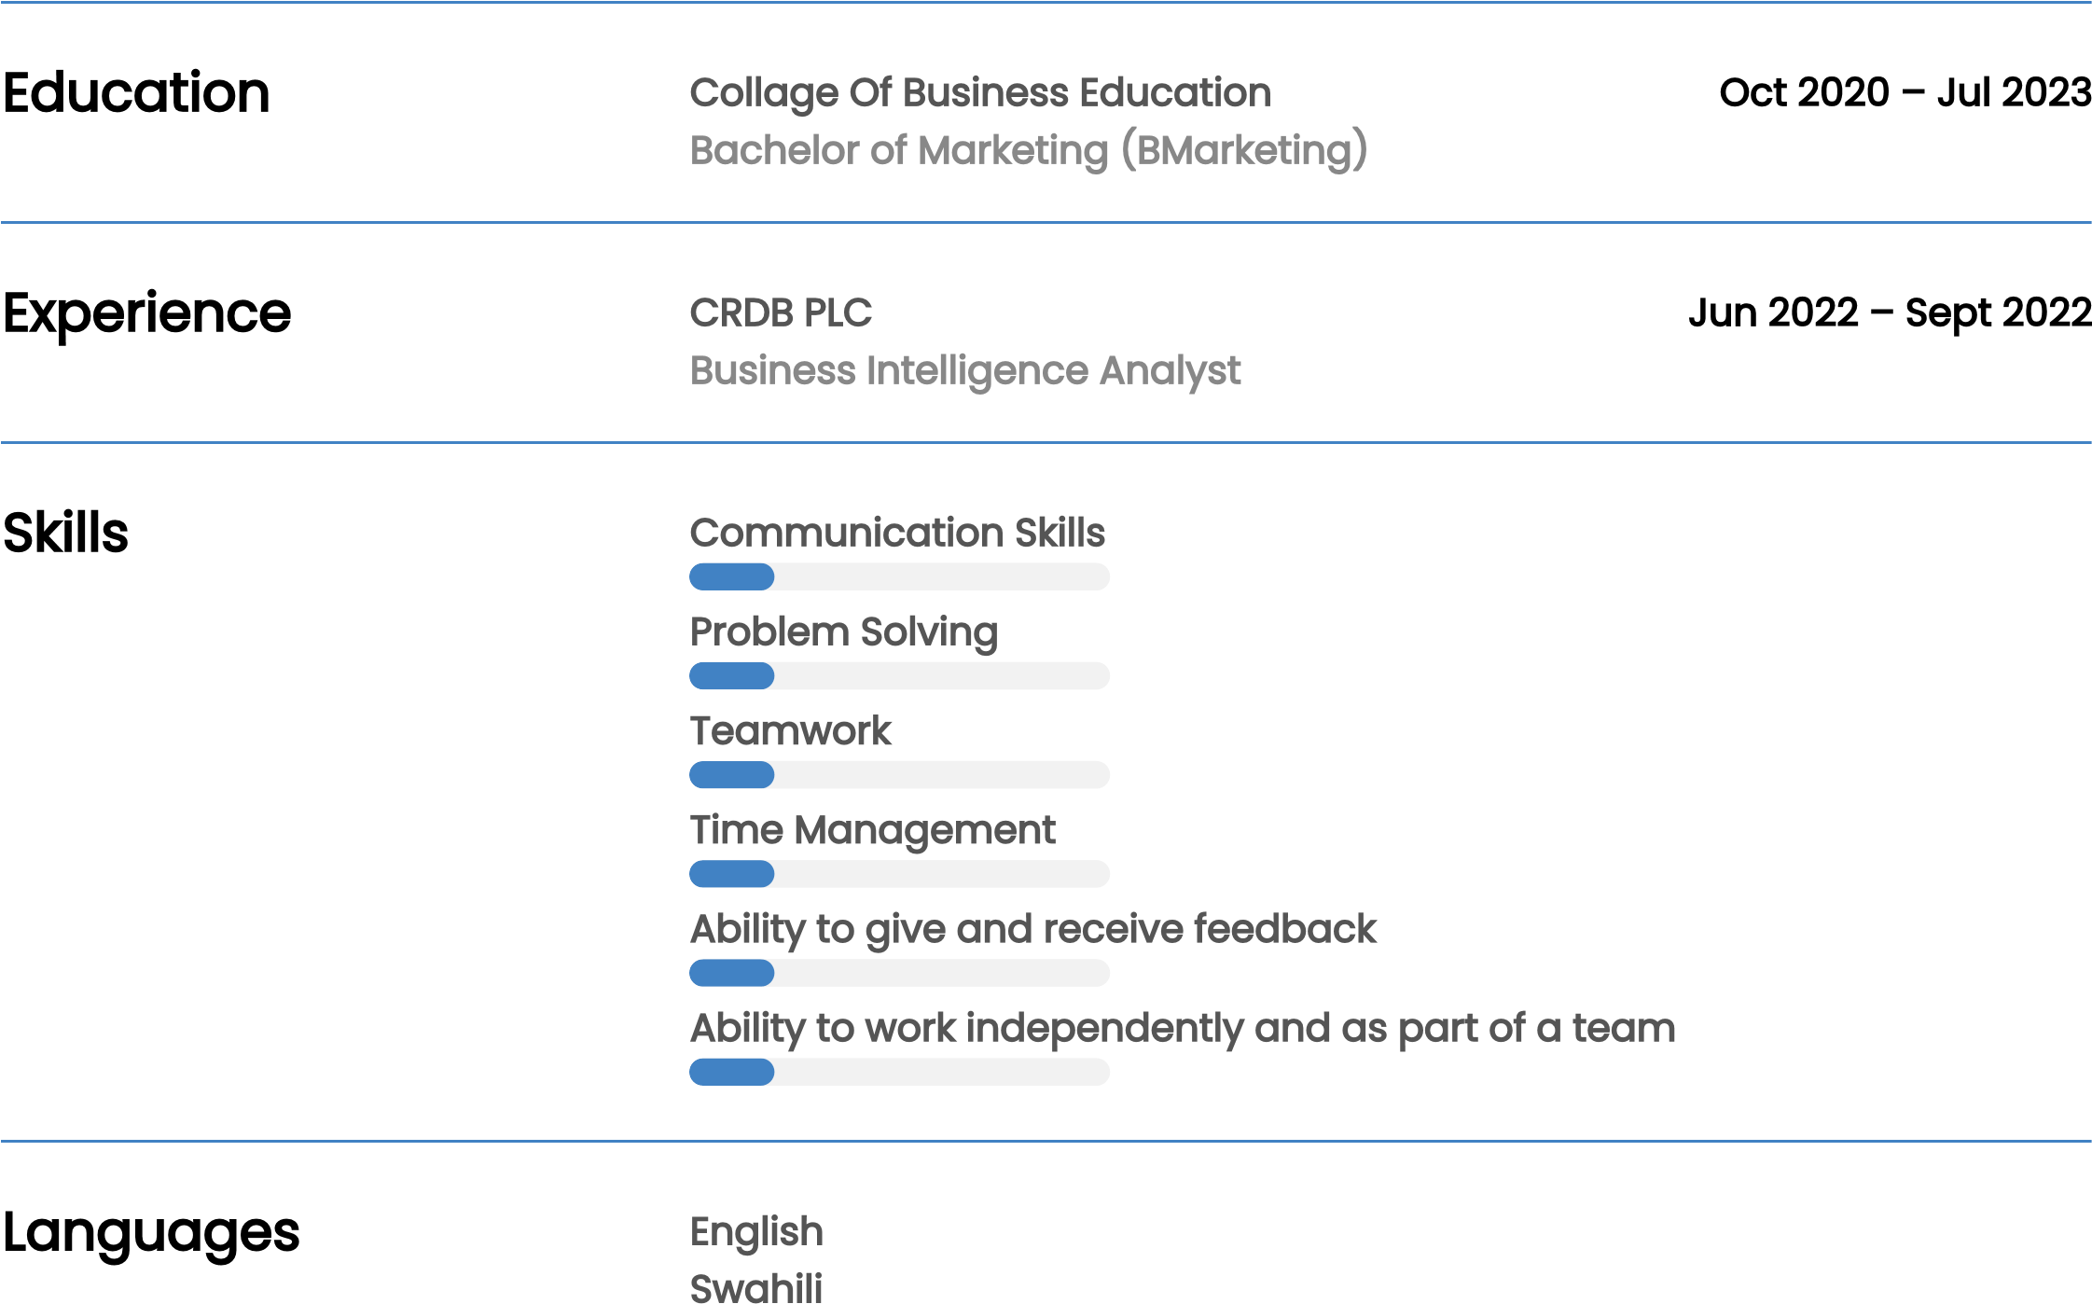Passionate about joining a dynamic team where I can utilize my experience and abilities to deliver exceptional results and contribute to the company's growth..