**CURRICULLUM VITAE (CV)**

**TRIO BROTHERS**

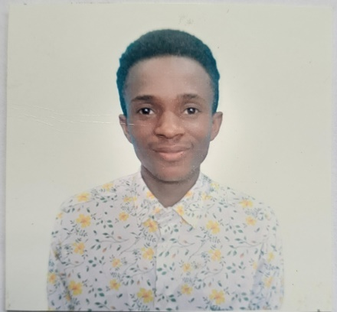  

Name: Mohamed Abasi Kitambulio Name: Hassan Ally Luhizo Name:Peter Denis Vedasto

Passport No; TAE244927 Passport No: TAE242023 Passport No: TAE243272

Panama No: PA0222386 Panama No: PA0250564 Panama No: PA0222392

Date of birth; 27 Jan 1995 Date of birth: 15 Dec 1992 Date of birth: 12 Jun 1996

Nationality; Tanzanian Nationality: Tanzanian Nationality: Tanzanian

Height;167.7cm Height:168.6cm Height:169.3cm

Weight:50kg Weight:60kg Weight:55kg

Sex :Male Sex :Male Sex :Male

Spoken Language :English and Swahili Spoken Language :English and Swahili Spoken Language :English and Swahili

**DISCIPLINE AND POSITION**

**Trio balance Act**

**DESCRIPTION**

Mohamed Abasi,Hassan Ally and Peter Denis are from Tanzania and are world Trio Brothers

performers, they has begun there career in 2016 with their Trio Ballance act. An outgoing talented

artists who bring energy to the stage they are for their known for their ability to blend grace strength

with thrilling acrobatics.

Hassan Ally Luhizo –Base

Peter Denis Vedasto- Middle

Mohamed Abasi Kitambulio-Fly

PERFORMANCE EXPERIENCE

* Trio Balance,Show Circus in Turkey From 2018 to 2019
* Trio Balance,Show Hotel in Turkey From 2019 to 2020
* Trio Balance,Show MSC SPLENDIDA CRUISE SHIP from 2022 to 2023
* Trio Balance,Show MSC SPLENDIDA CRUISE SHIP from 15 may 2023 to 24 Nov 2023
* Trio Balance,Show MSC POESIA WORLD CRUISE SHIP from 2023

**REFERENCE**

[hassamnoor7@gmail.com](mailto:hassamnoor7@gmail.com)

+255759181511

-Adress:Mtongani 547-15108,Dar-es-salaam