# CIRCULLUM VITAE

**CARRIER OBJECTIVE**

To utilize the acquired knowledge to the maximum of creativity to provide quality services and support to meet the organization goals set and maximizes its reputation.

# A.PERSONL PARTICAULARS:

* FULL NAME : BENARD SOSPETER KALEKWA
* DATE OF BIRTH : 20th September 2000
* GENDER : MALE
* MARITAL STATUS : SINGLE
* NATIONALITY : TANZANIAN
* LANGUAGE : KISWAHILI AND ENGLISH

# B.CONTACT ADDRESS:

* POSTAL ADDRESS : P.O. BOX 136, SENGEREMA-MWANZA
* EMAIL ADDRESS : **[benardkalekwa@gmail.com](mailto:benardkalekwa@gmail.com)**
* TELEPHONE NUMBER : 0710924510/0629655774

**C.EDUCATIONAL BACKGROUNDS AND QUALIFICATIONS:**

|  |  |  |  |
| --- | --- | --- | --- |
| **YEARS** | **INSTITUTIONS** | **MAJOR** | **AWARDS** |
| 2020 - 2023 | NATIONAL INSTITUTE OF TRANSPORT (NIT) | BACHELORS DEGREE IN ROAD AND RAILWAY  LOGISTICS TRANSPORT MANAGEMENT(BRRTLM) | CERTIFICATE OF BACHELOR’S DEGREE  IN ROAD AND RAILWAY LOGISTICS |
| 2018 - 2020 | KAHORORO SECONDARY SCHOOL- BUKOBA | ADVANCED SECONDARY EDUCATION LEVEL | CERTIFICATE OF SECONDARY IN ADVANCED LEVEL EDUCATION |
| 2013 - 2017 | ST. JOSEPH SOGA BOYS  SECONDARY SCHOOL - MAHENGE/ULANGA | SECONDARY EDUCATION LEVEL | CERTIFICATE OF  SECONDARY IN EDUCATION LEVEL |
| 2006 - 2012 | MIEMBENI PRIMARY SCHOOL - IFAKARA | PRIMARY EDUCATION LEVEL | CERTIFICATE OF PRIMARY LEVEL EDUCATION |

**D.SKILLS AND COMPETENCY**

1. **FLEET MANAGEMENT AND SAFETY**
   * Vehicle maintenance and care.
   * Transport budgeting and control.
   * Road Traffic Rules and Regulations.
   * Road Signs and Markings**.**

# COMPUTER APPLICATION

* + Excellent in Microsoft Word
  + Excellent in Microsoft Excel
  + Excellent in Microsoft Power point
  + Emailing and Internet

# OIL AND GAS SUPPLY CHAIN, CARGO SURVEY AND TRANSPORTATION

* + Oil and Gas value chain.
  + Petroleum products, LNG and LPG Transportation.
  + Marine Terminal operations for Oil and Gas.
  + Oil Tanker, LNG and LPG carrier Inspection and Cargo Survey.
  + Loading and Discharge of Oil and Gas Cargo.

# E.TRAINING,SEMINAR AND WORKSHOP.

|  |  |  |  |  |
| --- | --- | --- | --- | --- |
| **TYPES OF**  **TRAINING** | **PLACE** | **AWARDS** | **DURATION** | **YEAR** |
| Occupational Health and Safety Programme (OSHA) | Nyakahoja - Mwanza |  | 14 days | 2025 |
| Oil & Gas Supply chain, Cargo survey and Transportation | National Institute of Transport - Dar es  Salaam | Certification of Oil & Gas Supply chain, Cargo survey and  Transportation | 7 days | 2023 |
| National Service | Nachingwea JKT -  LINDI | Certification of  National Service | 3th july - 25th  september | 2020 |

**F.FIELD AND WORK EXPERIENCE**

* I volunteered in various organization and performed various activities during my field session. The following are bearings which i performed during my field work;
  + To create, update and publish the vehicle inventory.
  + To create, update and publish the vehicle information sheeet.
  + Preparation of period transport schedules.
  + To receive and check trip authorities as needed.
  + To keep and manage vehicle and safety equipments.
  + To raise awareness about transport issues.
  + To prepare period transport reports
  + Planning and arranging drivers assessment.
  + To ensuring safety and cleanliness of vehicles at all times.
  + Adhering to maintenance schedules.
  + To ensuring valid documents and equipment’s are available up to date.
  + To perform messenger duties such as dispatching /letters and collecting mails.
  + Requesting of new vehicles and replacing vehicles as needed.
* I attended in National service from 03th july – 25th september 2020 Operation “**UCHUMI WA KATI**” at Nachingwea JKT. During that service I learnt various bearings as follows;
  + Entrepreneurship
  + Patrol activities in and around the National service camp
  + Responding to emergency situations
  + Ensuring safety within the army camp.

# G.HOBBIES

* Reading different books and novels.
* Sports and games.
* Visiting National Parks

# H.REFEREES

* **Eng. Manyango B. Nchambi**

Registered Civil Engineer (PE 4991)

P.o Box 193, Kahama

E-mail: [nmanyango@gmail.com](mailto:nmanyango@gmail.com) Mobile: 0762 281 148

# Adv. Nathaniel A. Mude

Nabra Attoneys

P.o.Box 344, Musoma- Mara

E-mail: [nathan.mude@gmail.com](mailto:nathan.mude@gmail.com) Mobile: 0655 493 939

* **Hassan Abdallah Blam** District Land Officer P.o.Box 01, Mbogwe- Geita. Mobile: 0625 474 876

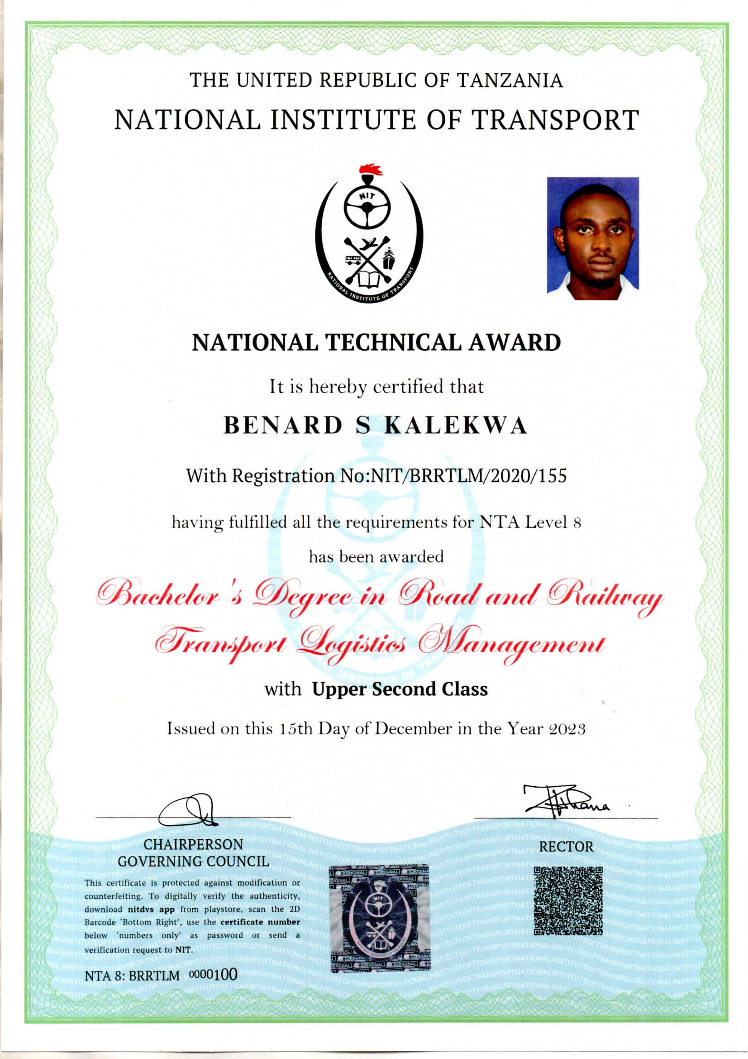

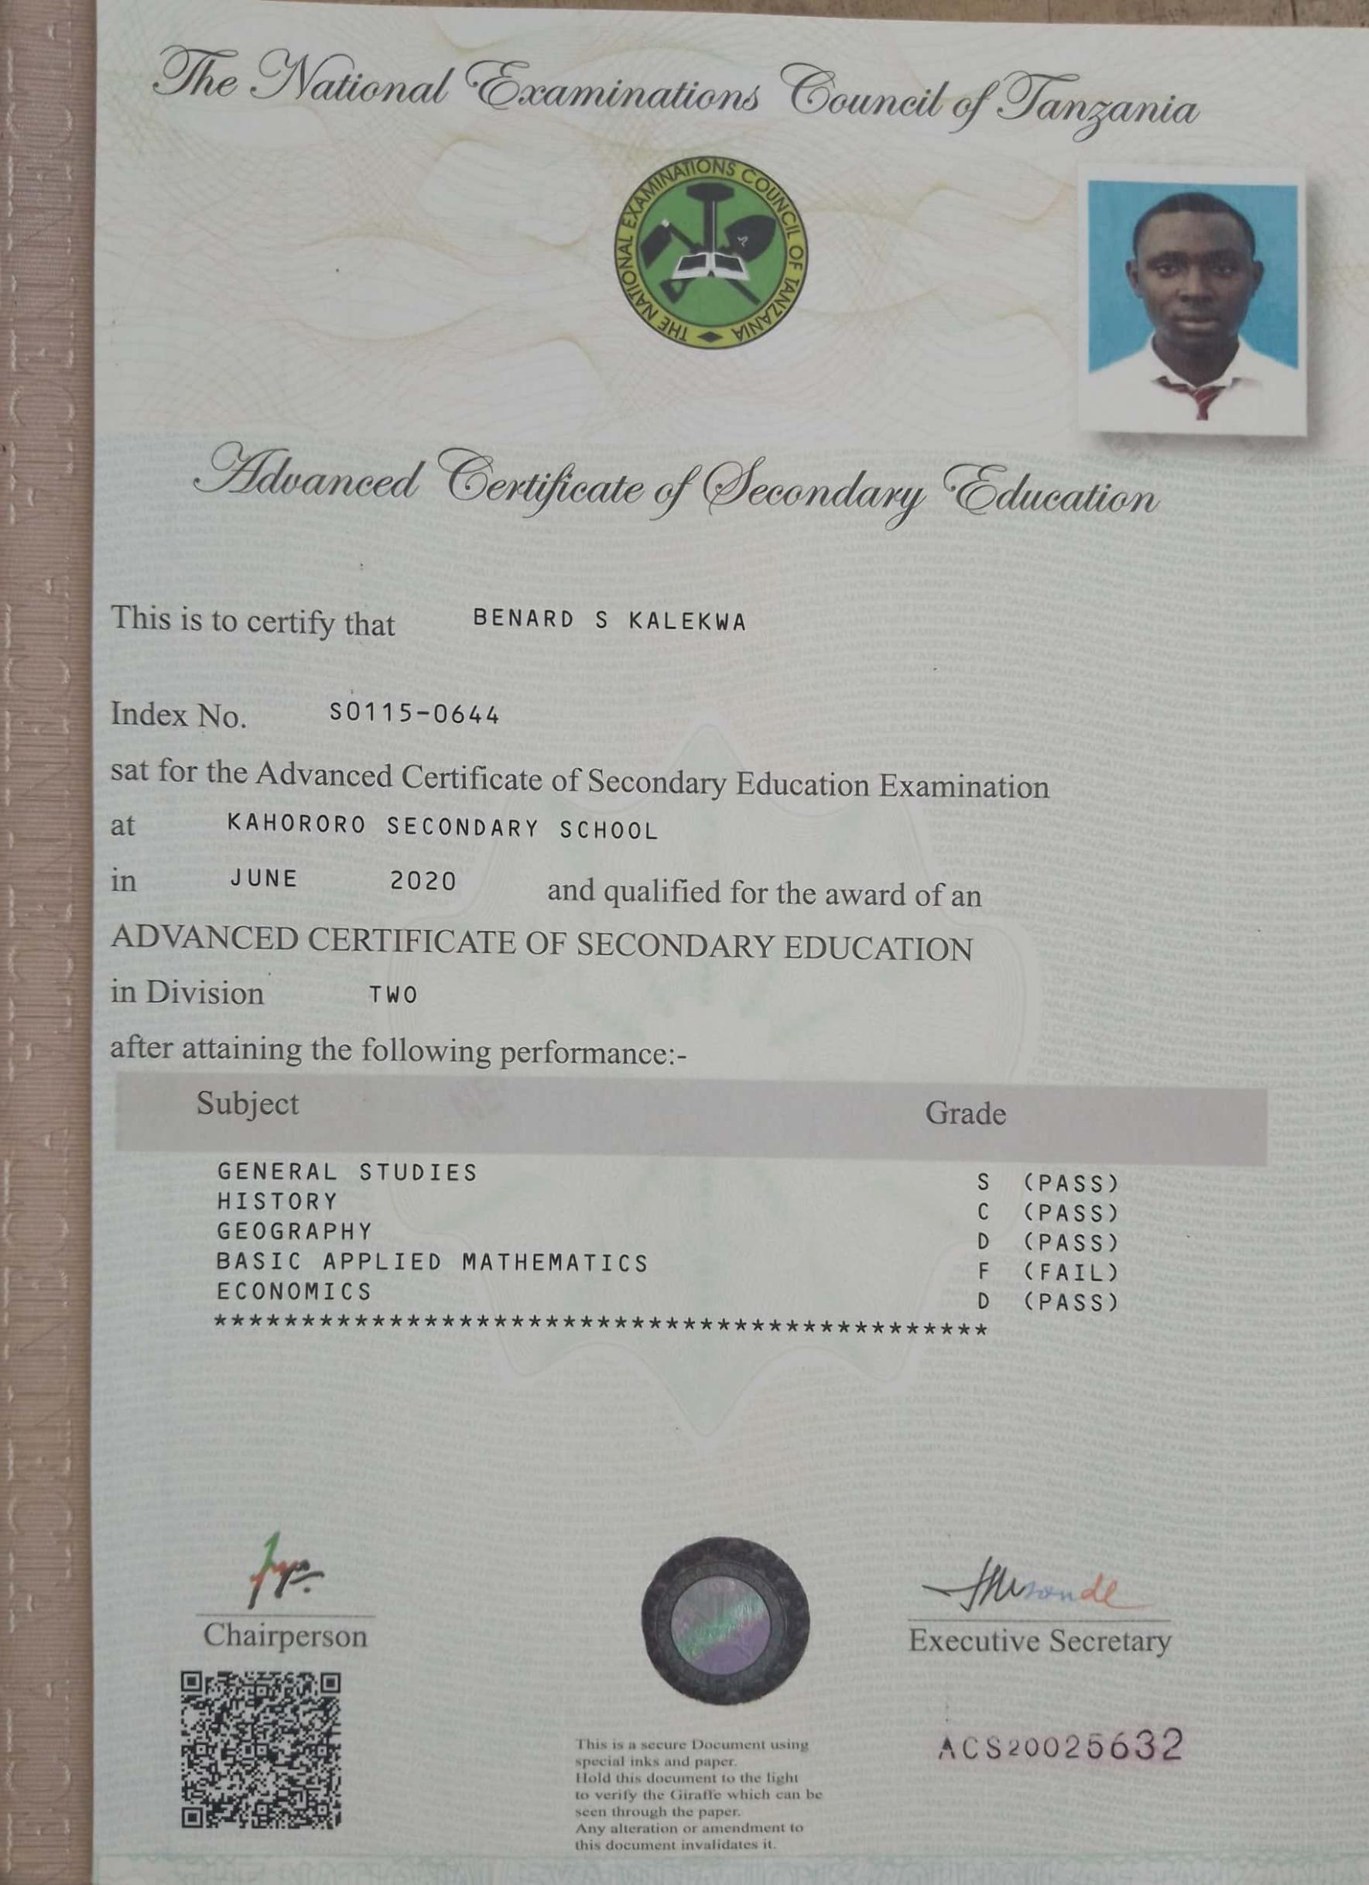

[CamScanner](https://digital-camscanner.onelink.me/P3GL/g26ffx3k)

